Drone Control

Final Report

August 22, 2019

Prepared by:
Clark Harrison Dy
Eric Zhang

Introduction
Advances in quadrotor technology have skyrocketed, allowing their potential to continue to grow the past few years. Due to the increasing versatility, it is clear that the next step would be automation.

Problem Statement
Our goal is to be able to use Computer Vision (with OpenCV) in order to control the AR.Drone 2.0 (the drone) autonomously. The drone had limited battery capacity, and so we only had limited testing time per recharge. Additionally, during the testing phase, we need to be connected to the drone via wifi in order to send the drone instructions, and since we intend on testing the drone’s functions while it is flying, we are unable to conduct testing inside the computer lab.

Drone Control
In order to control the drone, or robots in general, is with a collection of libraries bundled together into the Robot Operating System (ROS). Data is published and received through “topics,” a hub for information to be received from and given to by “publishers” and “subscribers” respectively. For example, information is published from the drone’s camera and read by an external program, which would send instructions to the drone via wifi (Figure 1).

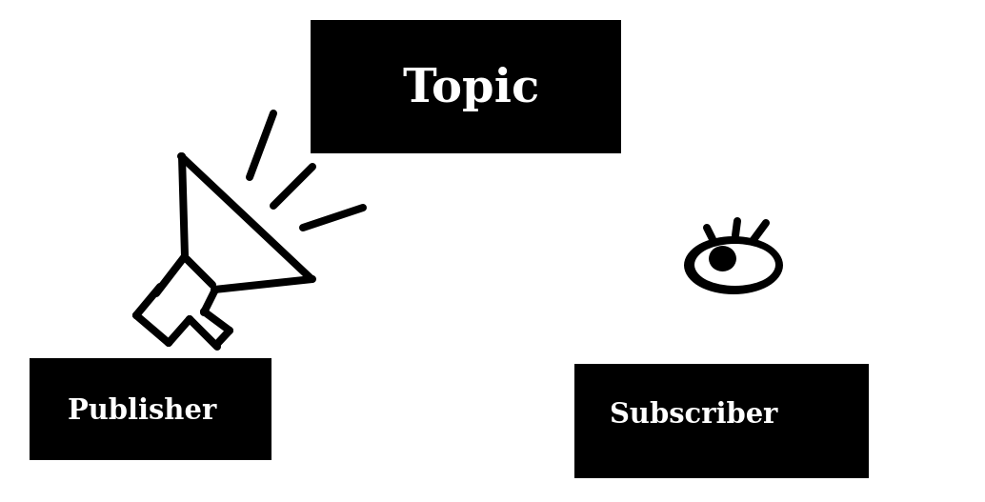
Figure 1: Publisher-Subscriber Relationship via Topic

Testing Process
Previously, we have mentioned that we were unable to pilot the drone inside the computer lab since it would be dangerous for the drone and the people within the lab. In order to partially remedy this problem, we installed a virtual machine running Ubuntu 16.04 on a laptop. This allowed us to pilot the drone in a relatively open space outside. The drone was flown in different environments, such as a grass field or a spacious indoor room within the Electrical Engineering building. However, many issues came with using a virtual machine. It was excessively difficult to transfer files to the virtual machine, using a shared folder that required the commands:

/media$ sudo cp sf_shared/file ~/drone_ws
/media$ cd ~/drone_ws
~/drone_ws$ sudo chmod 666 file
~/drone_ws$ sudo chown eric file
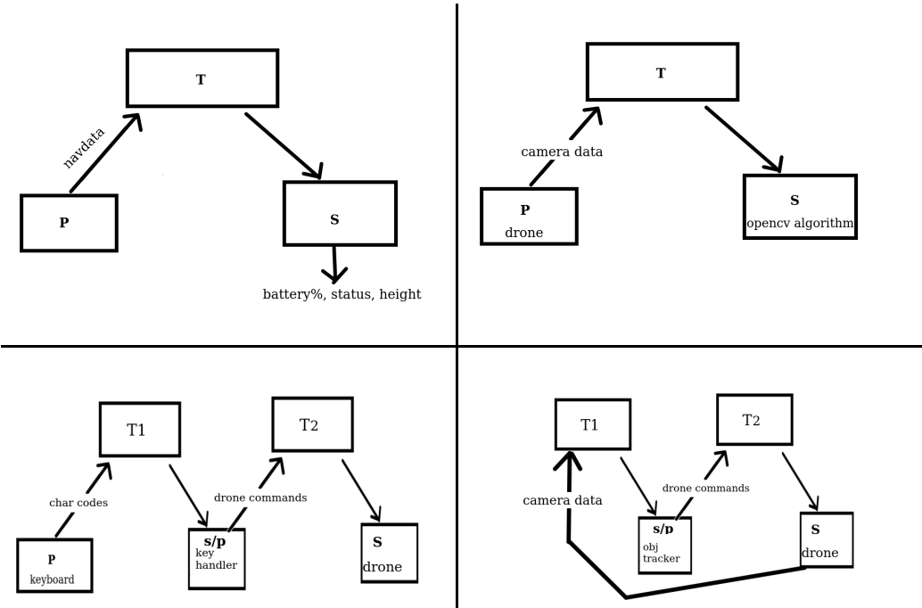
for every file, where “eric” is the user name. Essentially, the folder was read-only and all ownership rights had to be transferred as well as permissions granted. Otherwise, make (for c++, the language we used) would fail (since vm user eric has no read or write permission). Additionally, the virtual machine took a heavy toll on the laptop’s resources, resulting in it being slow and unresponsive. This was especially apparent in later test programs that would read and display images from the drone's camera and run an object tracking algorithm. However, virtual machine was the only real solution apart from lugging a desktop setup to another room. Our primary goal was to read data from the drone. This led to the creation of a status updater program (Figure 2a) and a camera feed program (Figure 2b). After connection was established, we needed that commands could be given to the drone. This led to the basic key-input program that allowed for drone control (Figure 2c). Due to time constraints, we were unable to implement and object tracking program, as outlined in (Figure 2d), where the drone’s camera feedback would control the drone as a response to the image processing algorithm.

Figure 2 (Left to Right, Top to Bottom): a) Read Navdata from drone. b) Read Camera data from the drone. c) Keyboard Controller. d) Use feedback from drone’s camera

Results
qwrqwrqwrwerewrwerewr

Conclusion

